Dear SCISS participants!  
  
It was an honour and a pleasure to meet you all on Monday, and I wanted to let you know that I greatly enjoyed our session, with some fascinating questions and issues raised by you. Since we ran out of time – and here I apologise once again to you and Łukasz & Co. for cutting into the lunch time - I wanted to share some of the material from the presentation that got left out. I wanted to share some examples of researchers who effectively leverage their social media use and have been an inspiration to me.

1. Prof. Laurent Pech -

Dean of UCD School of Law, professor of EU law and a very proactive and vocal legal scholar who uses his formerly Twitter/X and now Bluesky presence to leverage his messaging, promote his research and advocate for causes he’s passionate about. Notably, Prof. Pech is known for his strategic litigation against EU institutions regarding the release of documents and public information. He has also utilised social media to raise awareness about the issues and inform the public about the progress of his court cases.

1. Dr Silvia Steininger -

A very active junior German scholar in public and international law, focused on several key areas: communication of courts with the general public, the case law of the European Court of Human Rights, suppression of academic freedom, and experiences of scholars from disadvantaged backgrounds. Silvia combines her legal analysis with the adventures of her dog, Olivia, and her experiences of living and working in Germany.

1. Prof. Ben Stanley - @benstanley.eu (Bluesky)

British professor of political science residing in Poland and working at SWPS University in Warsaw. His focus is on Polish politics and the antidemocratic turn Poland took in 2015, and he combines qualitative and quantitative analysis with a distinctly British-Polish sense of humour. Notably, Ben strategically positions his research on political support polling near elections and referendums, ensuring high engagement with journalists seeking predictions of election results and explanations for trends in political support.

1. Dr Corina Heri -

Junior Swiss scholar of international law who went viral with her coverage of the Kilmaseniorinnen case – an ECtHR case about an organisation of elderly Swiss ladies taking the government before courts over inaction with regards to the climate crisis. Corina’s excellent use of social media to explain her research in simple terms led to Swiss online magazine Republik hiring her to carry out conversations with a diverse group of interlocutors – a primary school pupil, a high school pupil, a B.A. student and an attorney – on the legal aspects of climate change (video in German, but YT translation should work good enough). A very interesting success story in communicating research but also of legal scholars going outside of their usual comfort zone in engaging with diverse audience.

[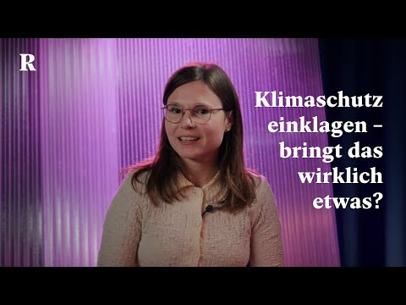](https://www.youtube.com/embed/WFXe8LOsMKo?feature=oembed)

I hope these examples are helpful. If you'd like to stay in touch, you can find me on LinkedIn and Bluesky (